It is recommended that the Energy Modelling Report be submitted in the following format. Text in closed brackets and italics gives guidance on the information required and is not to be included in the final report. Note no examples of as-built documentation correlating the actual equipment included on the project to what has been included in the model are provided. Project teams are however expected to provide this information with their modeling report with all relevant information highlighted.

# General Modelling Parameters

* Project *XYZ Office*
* Number of Stories *1*
* Location *Johannesburg*
* Simulation Software used *DesignBuilder v3.1*
* Weather Data Used *Meteonorm O.R.Tambo/Jan Smuts Airport 1996-2005*
* Space Breakdown:

Table 1Space break down

|  |  |  |  |  |
| --- | --- | --- | --- | --- |
| **Space** | **Type** | **Included in**  **simulation** | **Area (m²)** | **Comments** |
| *Reception* | *Office* | *yes* | *50* |  |
| *Office* | *Office* | *yes* | *1674* |  |
| *Stairwell* | *Office* | *yes* | *46* |  |
| *Ablutions* | *Office* | *yes* | *80* | *Extract fan energy use excluded from calculations* |
| ***TOTAL*** |  |  | ***2537*** |  |

*[Justification for any areas of the project excluded from the model]*

Car park lighting, lifts and escalators and ventilation energy were excluded from the calculations. The tenant is fitting out an existing building and had no influence on the design of these areas.

*[Details of any central plant which serves areas other than the modelled area, and how these have been dealt with]*

No central plant serving other areas is included on this project

**Naturally Ventilated Buildings**

*[Confirmation that the Natural ventilation comfort criteria has been met or not, and details of modelling to show compliance – either in the energy modelling report or as a separate Natural Ventilation Report – refer Green Star SA Technical Manual – credit Ene-1]*

The project is an artificially air conditioned building.

# Energy Efficiency Measures

[*Provide a brief description of the items that contributes to the energy efficiency results obtained]*

The building has been designed to reduce thermal loads on the HVAC system as much as possible. External shading has been provided on all facades except the south.

Energy efficient lighting that saves electrical energy and reduces the thermal load on the HVAC system is used on the project.

The building makes good use of thermal mass by exposing the ceilings and floor, this reduces energy consumption on the HVAC system and improves thermal comfort, particularly in perimeter zones.

The air conditioning system itself (VRF system) is energy efficient and can perform simultaneous heating and cooling. High part load COPs that exceed that of the reference building can be obtained.

# Building Envelope

## Geometry

The fitout consists of the entire 2nd floor of the recently completed XYZ building in Johannesburg.

*[Isometrics of the simulation model for both the Actual and the Notional Building showing the building shape and window locations, etc, that allows easy comparison with architectural drawings]*

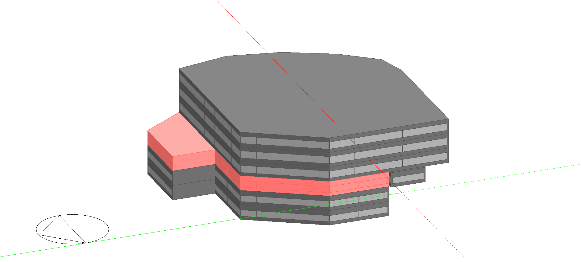

Figure 1 Notional building model

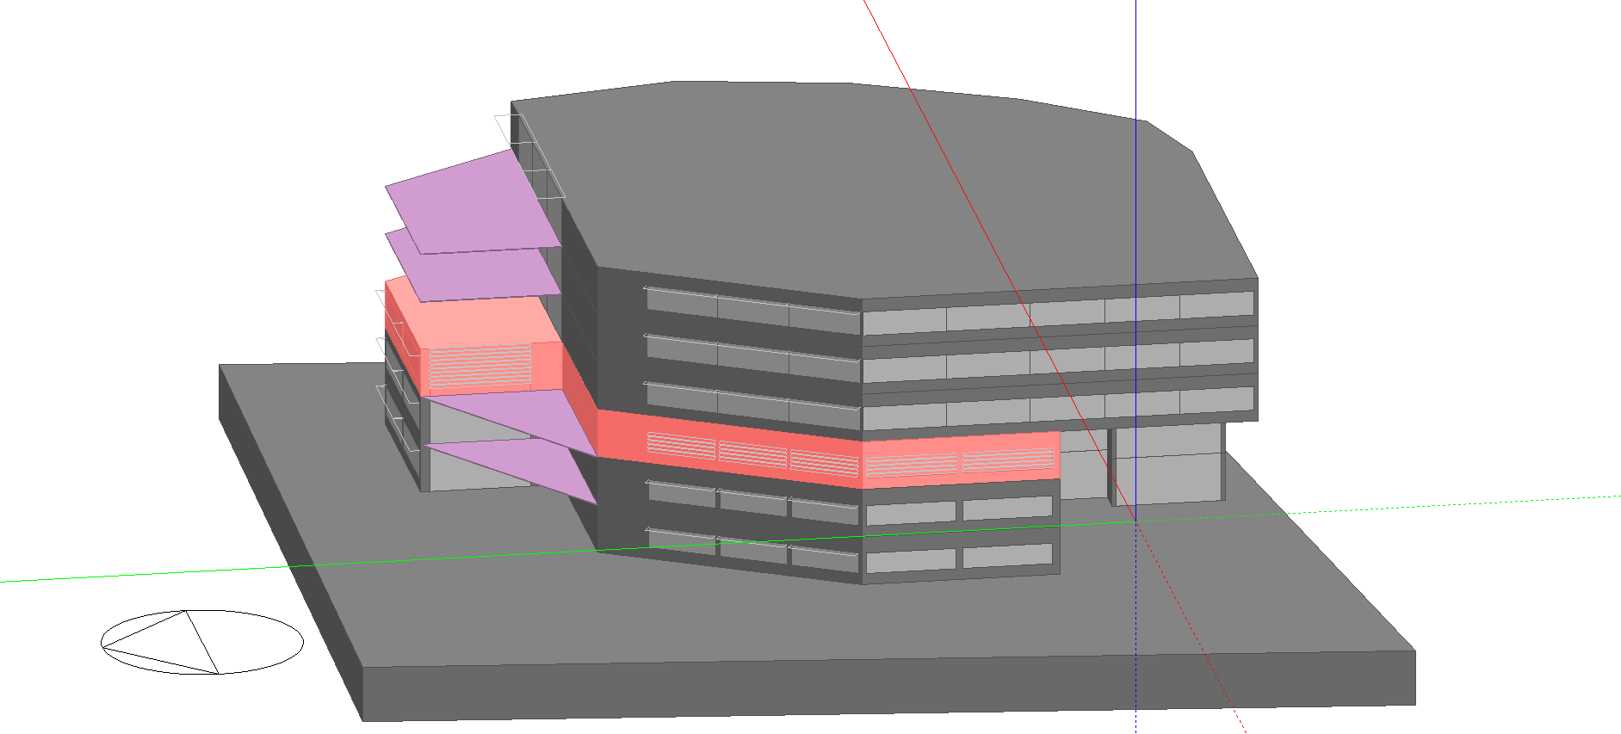

Figure 2 Actual building model

## Fabric

### Opaque building fabric

Table 2 Opaque fabric elements summary

|  |  |  |
| --- | --- | --- |
|  | **Notional Building** | **Actual Building** |
| **Exterior Wall Construction** | 110mm brick,15mm Standard EPS Insulation,110mm brick,10mm plaster Insulation  R=0.891  CR = 80 | 110mm brick, 50mm air cavity,110mm brick  R = 0.6 |
| **Roof** | N/A | N/A |
| **Internal Floor/Ceiling** | 10mm Wooden floor,150mm air gap,150mm concrete slab,500mm air gap,10mm ceiling tile  R=1 | 200mm skimmed concrete slab  R= 0.4 |

### Glazing

Table 3 Vertical glazing summary

|  |  |  |
| --- | --- | --- |
|  | **Notional Building** | **Actual Building** |
| **Window Type** | SANS 204 Double Glazed, Timber Frame, Solar Coating | Double Glazed Low-e |
| **Average U value including frame** | 4.23 | 2.2* |
| **SHGC** | 0.59 | 0.51 |

*Aluminium frames are drawn geometrically in the model as per glazing schedules, total U-value is calculated by the modeling software.

Table 4 Notional building glazing area calculation

|  |  |  |  |  |
| --- | --- | --- | --- | --- |
|  | **Notional Building** |  |  |  |
| **Floor(s)** | GFA | Perimeter | Required area of glazing at 15% of GFA | Glazing height at 15% of GFA |
| **2nd Floor** | 1818 | 187 | 272 | 1.45m |

A continuous strip of glazing with height as per the calculation above was distributed on all the facades of the notional building.

### Roof lights

Table 5 Rooflight summary

|  |  |  |
| --- | --- | --- |
|  | **Notional Building** | **Actual Building** |
| **Rooflight Type** | SANS 204 minimum standard | N/A |
| **Rooflight area (m²)** | N/A | N/A |
| **Average U value including frame** | N/A | N/A |
| **SHGC** | N/A | N/A |

### Shading

*[Details of internal and external shading included in simulation]*

No shading was modeled for the notional building. All shading elements as per architects drawings were included in the actual building. These were as per the summary below and have been marked up on the architects drawings.

Table 6 Actual building shading summary

|  |  |
| --- | --- |
| Location | **Description** |
| **West facing glass** | Horizontal louvres with a 300mm spacing, 300mm blade depth and angled at 30° to the horizontal |
| **North facing glass** | 2m overhang placed 500mm above glazing. |
| **East facing glass** | Horizontal louvres with a 300mm spacing, 300mm blade depth and angled at 30° to the horizontal |

## Orientation

*[Evidence that orientation of the building has been taken into account]*

*The building orientation was as per architects drawing. The correct orientation has been marked up on the architects drawings provided.*

## Infiltration

Infiltration for perimeter zones was set as below;

Table 7 Infiltration

|  |  |  |
| --- | --- | --- |
|  | **Notional Building** | **Actual Building** |
| **Infiltration rate** | 0.5ach | 0.5ach |

## Internal Loads

|  |  |  |
| --- | --- | --- |
|  | **Notional Building** | **Actual Building** |
| **Summer Design temperature** | 23°C | 23°C |
| **Winter Design Temperature** | 21°C | 21°C |
| **Occupancy** | 9 m²/person | 9 m²/person |
| **Tenant lighting** | 11 W/m² | 6 W/m² |
| **Tenant equipment** | 11 W/m² | 11 W/m² |
| **Fresh air rate** | 7.5 litres/sec/person | 10 litres/sec/person |

## HVAC Systems

### Zoning

The same zoning was used for both the notional and actual building. This zoning was exactly as per the mechanical engineers design.

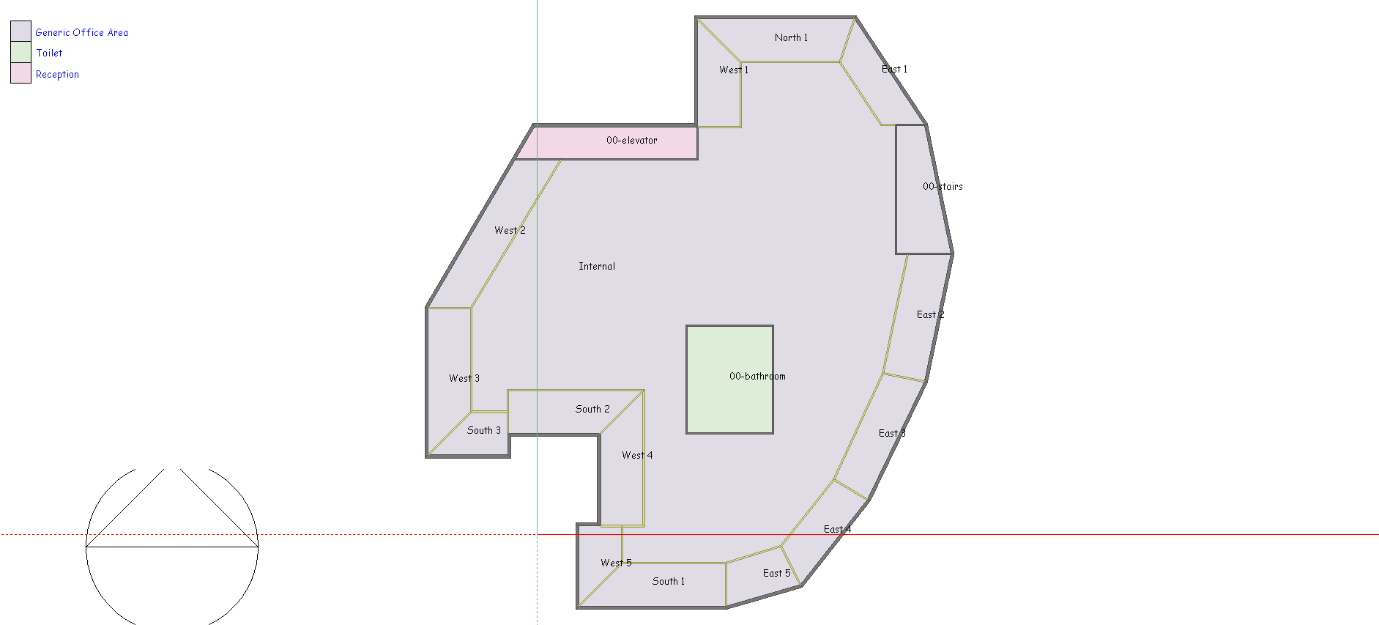

### Notional building HVAC

HVAC system 2 was used for the notional building since the project consisted of a floor less than 3 500m². Notional building system inputs were as per the table below

|  |  |
| --- | --- |
| System Component | Performance Parameter |
| Unitary heat pump | Cooling COP of 3 and heating COP of 3.2. |
| Supply air temperature | 12° C |
| Supply Air fan power | Constant volume fan with a specific fan power of 0.8 W/l/s and an overall fan efficiency of 70%. This equates to a standard fan coil unit. |
| Zoning | Thermal zones as per proposed building with one air unitary heat pump object per zone. |

### Actual Building

*[Description of the HVAC system, including number and kW rating of chillers, plant efficiency (COP) etc, number and duty of air handling units/split units etc. Note the actual capacities of equipment are to be used]*

#### Cooling and heat rejection

The actual building makes use of a VRF system for heating and cooling. VRF energy consumption was modeled using data from manufacturer’s documentation for the specified equipment. A single outdoor unit as per the design was modeled. The table below shows a summary of the actual building energy inputs.

Table 8 Notional building HVAC components parameters

|  |  |  |
| --- | --- | --- |
| System Component | Rated Capacity (kW) | Note |
| Outdoor unit - Cooling | 125 | The actual design capacity is used |
| Outdoor unit capacity- Heating | 150 |  |

Table 9 VRF outdoor unit performance data

|  |  |  |  |  |  |  |  |
| --- | --- | --- | --- | --- | --- | --- | --- |
|  |  | Outdoor Temperature | | | | |  |
|  |  | 18°C | 20°C | 23°C | 27°C | 31°C |  |
| % Part Load | 50.00% | 5.95 | 5.86 | 5.72 | 5.43 | 4.84 | COP Cooling/Heating |
| 60.00% | 6.02 | 5.93 | 5.76 | 5.35 | 4.75 |
| 70.00% | 6.03 | 5.92 | 5.73 | 5.22 | 4.60 |
| 80.00% | 5.96 | 5.87 | 5.70 | 5.02 | 4.43 |
| 90.00% | 5.91 | 5.79 | 5.51 | 4.83 | 4.26 |
| 100.00% | 5.84 | 5.74 | 5.31 | 4.66 | 4.09 |

#### Supply Air Fans

Since the indoor units are constant volume fan coil units that also supply fresh air from a rear mounted plenum box into the space, supply air fan energy consumption was calculated by taking the total installed fan power and multiplying by the total number of HVAC hours. **F**an power as per the product data sheets provided for each specified fan are given below. Flow rate was entered as per the design flow rate indicated on the mechanical engineers drawings.

Table 10 Fan power of installed indoor units

|  |  |  |
| --- | --- | --- |
| **Model Reference** | **Design Flow Rate**  **(m³/s)** | **Fan Power (w)** |
| EAST3 SUPPLY FAN | 0.25 | 130 |
| EAST4 SUPPLY FAN | 0.25 | 130 |
| EAST5 SUPPLY FAN | 0.15 | 80 |
| SOUTH3 SUPPLY FAN | 0.15 | 80 |
| WEST4 SUPPLY FAN | 0.4 | 200 |
| INTERNAL SUPPLY FAN | 3.5 | 1700 |
| SOUTH2 SUPPLY FAN | 0.25 | 130 |
| EAST1 SUPPLY FAN | 0.25 | 130 |
| EAST2 SUPPLY FAN | 0.25 | 130 |
| WEST2 SUPPLY FAN | 0.45 | 225 |
| WEST3 SUPPLY FAN | 0.4 | 200 |
| WEST5 SUPPLY FAN | 0.15 | 80 |
| WEST1 SUPPLY FAN | 0.4 | 200 |
| NORTH1 SUPPLY FAN | 0.25 | 130 |
| SOUTH1 SUPPLY FAN | 0.4 | 200 |
| Fresh Air Fan | 2 | 2000 |

Fresh air is delivered by a constant volume fresh air fan and is included in the table above.

## Extract and Miscellaneous Fans

*[Details of car park and miscellaneous extract fans energy use]*

N/A

## Lighting

*[Details of tenant, common area, car park and external lighting calculations. Where occupancy sensors or other controls are assumed giving full details]*

Lighting information for all areas that fall under the fitout were calculated as per the electrical engineers drawings. Marked up drawings showing the inputs used for all calculations have been provided. The project meets all the requirements for occupancy sensing as per the deemed to satisfy criteria for lighting controls. A 15% saving in annual energy use is therefore claimed.

Table 11 Lighting energy calculations

|  |  |  |  |  |  |  |  |  |
| --- | --- | --- | --- | --- | --- | --- | --- | --- |
| Common Parameters | | | Notional Building | | Actual Building | | | |
| Space Type | Area | Annual Hours of Operation | Lighting Power Density [W/m²] | Annual Energy Use [kWh/yr] | Total Installed Lighting [kW] | Lighting Power Density [W/m²] | Annual Energy Use [kWh/yr] | Annual Energy Use (Occ Sensors) [kWh/yr] |
| Office | 1674 | 3016 | 11 | 55 536 | 9.5 | 6 | 28 652 | 24 354 |
| Common Areas | 176 | 3445 | 6 | 3 637 | 0.4 | 2 | 1 378 | 1 378 |
| **Total Annual Energy Consumption (kWh/year)** | | | | **59174** | **Total Annual Energy Consumption (kWh/year)** | | | **25 732** |

## Tenant equipment

The project meets the criteria for 1 point under the deemed to satisfy route for tenant equipment. A saving of 20% on annual energy use is therefore claimed. Documentation showing compliance with the deemed to satisfy criteria has been provided.

Table 12 Tenant equipment energy calculations

|  |  |  |  |  |  |  |  |
| --- | --- | --- | --- | --- | --- | --- | --- |
| Common Parameters | | | Notional Building | | Actual Building | | |
| Space Type | Area | Annual Hours of Operation | Equipment Power Density [W/m²] | Annual Energy Use [kWh/yr] | Equipment Power Density [W/m²] | Annual Energy Use [kWh/yr] | Annual Energy Use (Occ Sensors) [kWh/yr] |
| Office | 1674 | 3328 | 11 | 61 281 | 11 | 61 281 | 49 025 |
| Common Areas | 176 | 8760 | 0 | 0 | 0 | 0 | 0 |
| Total Annual Energy Consumption (kWh/year) | | | | 61 281 | Total Annual Energy Consumption (kWh/year) | | 49 025 |

## Domestic Hot Water

*[Excerpt from DHW calculator showing inputs used and final results]*

No domestic hot water heating is provided for this project.

## Lifts & Escalators

*[Excerpt from lift calculator showing inputs used and final results]*

N/A

## Renewable Energy & Cogeneration

*[Full details of systems proposed, and how annual energy consumption/generation figures have been calculated]*

N/A

## Unmet load hours

*[Number of hours when the stated internal design temperatures for air conditioned zones were not achieved. The proposed and reference buildings unmet load hours are not to exceed 300.Where the proposed building’s unmet load hours exceed the reference building unmet load hours by more than 50, the capacity of equipment in the notional building is to be reduced until the difference in unmet load hours is less than 50 )]*

|  |  |  |  |
| --- | --- | --- | --- |
|  | *Proposed Building* | *Notrional building* | *Difference* |
| *Number of hours heating load unmet* | *9* | *7* | *2* |
| *Number of hours cooling loads unmet* | *215* | *195* | *20* |

**Sign off**

*[Confirmation of name and company of person carrying out the modelling, and signed confirmation that they believe the results to be accurate to the best of their knowledge]*